API Key credential
# Source: AI Source: Provided by: [Data Path: Persons Table -> ID Column: 1, Name_En Column: Motasem Essam] -> From: [ChatGPT] on [1/18/2026]
An API Key credential is a secret value used to identify and authenticate an application (not a human) when it talks to an API.

🔑 What is an API Key?
# Source: AI Source: Provided by: [Data Path: Persons Table -> ID Column: 1, Name_En Column: Motasem Essam] -> From: [ChatGPT] on [1/18/2026]
A long, random string issued by a service to a client app.
Example
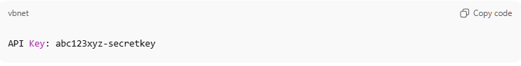
API Key: abc123xyz-secretkey

🛠️ How it works
# Source: AI Source: Provided by: [Data Path: Persons Table -> ID Column: 1, Name_En Column: Motasem Essam] -> From: [ChatGPT] on [1/18/2026]
- You request an API key from a service (e.g., Google, OpenAI, AWS)
- The service gives you a unique key
- Your app sends the key with each API request
- The server checks the key
- If valid → request is allowed

📦 How it’s sent
# Source: AI Source: Provided by: [Data Path: Persons Table -> ID Column: 1, Name_En Column: Motasem Essam] -> From: [ChatGPT] on [1/18/2026]
Common ways API keys are included in requests:
HTTP Header
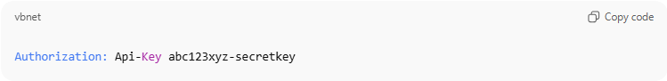
Authorization: Api-Key abc123xyz-secretkey
Custom Header
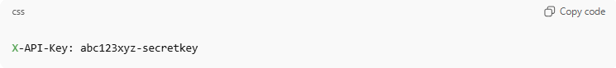
X-API-Key: abc123xyz-secretkey
Query Parameter (not recommended)
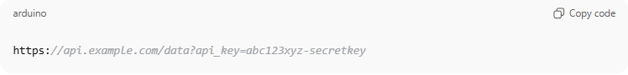
https://api.example.com/data?api_key=abc123xyz-secretkey

📍 Where it’s used
# Source: AI Source: Provided by: [Data Path: Persons Table -> ID Column: 1, Name_En Column: Motasem Essam] -> From: [ChatGPT] on [1/18/2026]
- Accessing REST APIs
- Cloud services
- Payment gateways
- Maps, weather, AI services
- Internal microservices

✅ Advantages
# Source: AI Source: Provided by: [Data Path: Persons Table -> ID Column: 1, Name_En Column: Motasem Essam] -> From: [ChatGPT] on [1/18/2026]
- Simple to use
- Fast authentication
- Good for server-to-server communication

⚠️ Disadvantages
# Source: AI Source: Provided by: [Data Path: Persons Table -> ID Column: 1, Name_En Column: Motasem Essam] -> From: [ChatGPT] on [1/18/2026]
- Not user-specific
- Can be leaked if exposed in code or URLs
- Usually no built-in expiration
- Not as secure as OAuth or tokens

🔒 Best practices
# Source: AI Source: Provided by: [Data Path: Persons Table -> ID Column: 1, Name_En Column: Motasem Essam] -> From: [ChatGPT] on [1/18/2026]
- Store in environment variables
- Never commit API keys to Git
- Rotate keys regularly
- Restrict by IP, domain, or scope
- Use HTTPS only

🧠 Authentication factor
# Source: AI Source: Provided by: [Data Path: Persons Table -> ID Column: 1, Name_En Column: Motasem Essam] -> From: [ChatGPT] on [1/18/2026]
- Falls under: Something you have

🆚 API Key vs Token (quick)
# Source: AI Source: Provided by: [Data Path: Persons Table -> ID Column: 1, Name_En Column: Motasem Essam] -> From: [ChatGPT] on [1/18/2026]
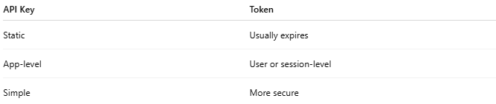
API Key | Token
Static | Usually expires
App-level | User or session-level
Simple | More secure

